Chapter 4, Problem 64.

Obtain the Thevenin equivalent seen at terminals a-b of the circuit in Fig. 4.130.

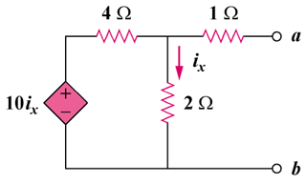

Figure 4.130
For Prob. 4.64.

